PROJECT-3

**DEPLOYMENT OF PYTHON WEB APPLICATION IN AWS**

**Procedure 1: Manual process**

Step-1 :Login into your AWS console and create an instance with an Ubuntu machine with instance type t2.medium.

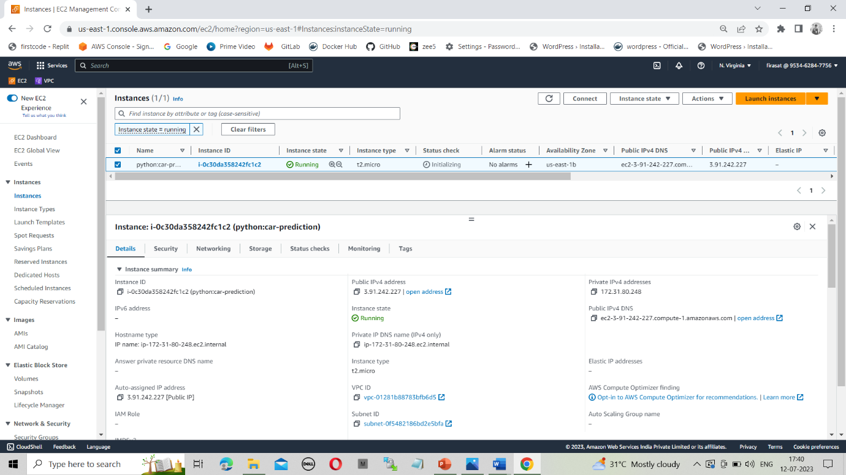

Step-2: Now open the terminal and connect to the instance through the SSH key.

Step-3 Now update the machine by using the command

* Sudo apt update -y

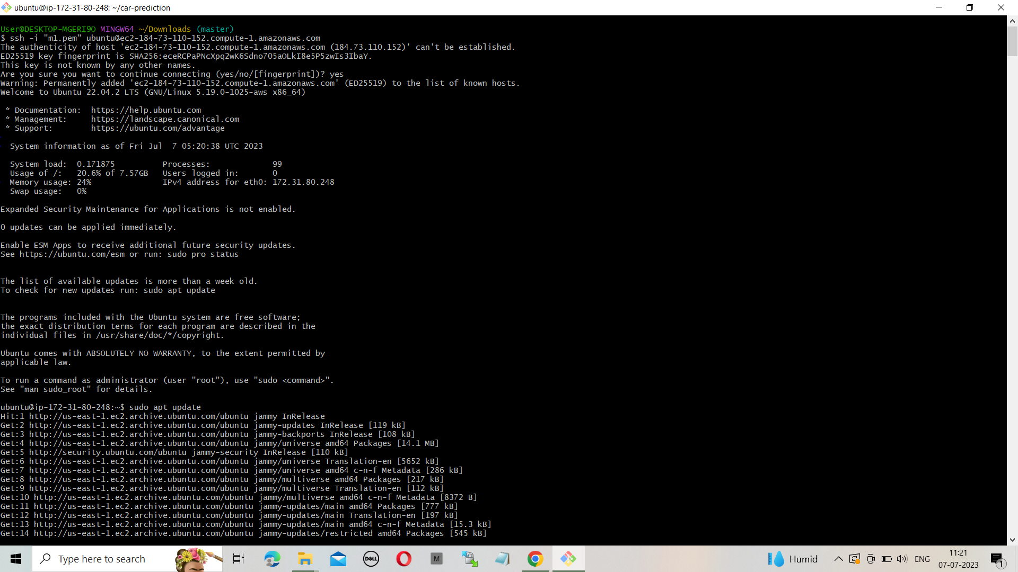

Step-4: Upgrade the machine by using the command

* Sudo apt-get full-upgrade –y

Step-5: Now install python3 and pip by using the following commands

* Sudo apt install python3
* Sudo apt install python3-pip

Step-6: Now clone the code from your repository by using the command.

* Git clone <https://github.com/TGouriSankar/car-prediction.git>

Step-7: Now go to that directory and install all the requirements by using the command

* pip install -r requirements.txt

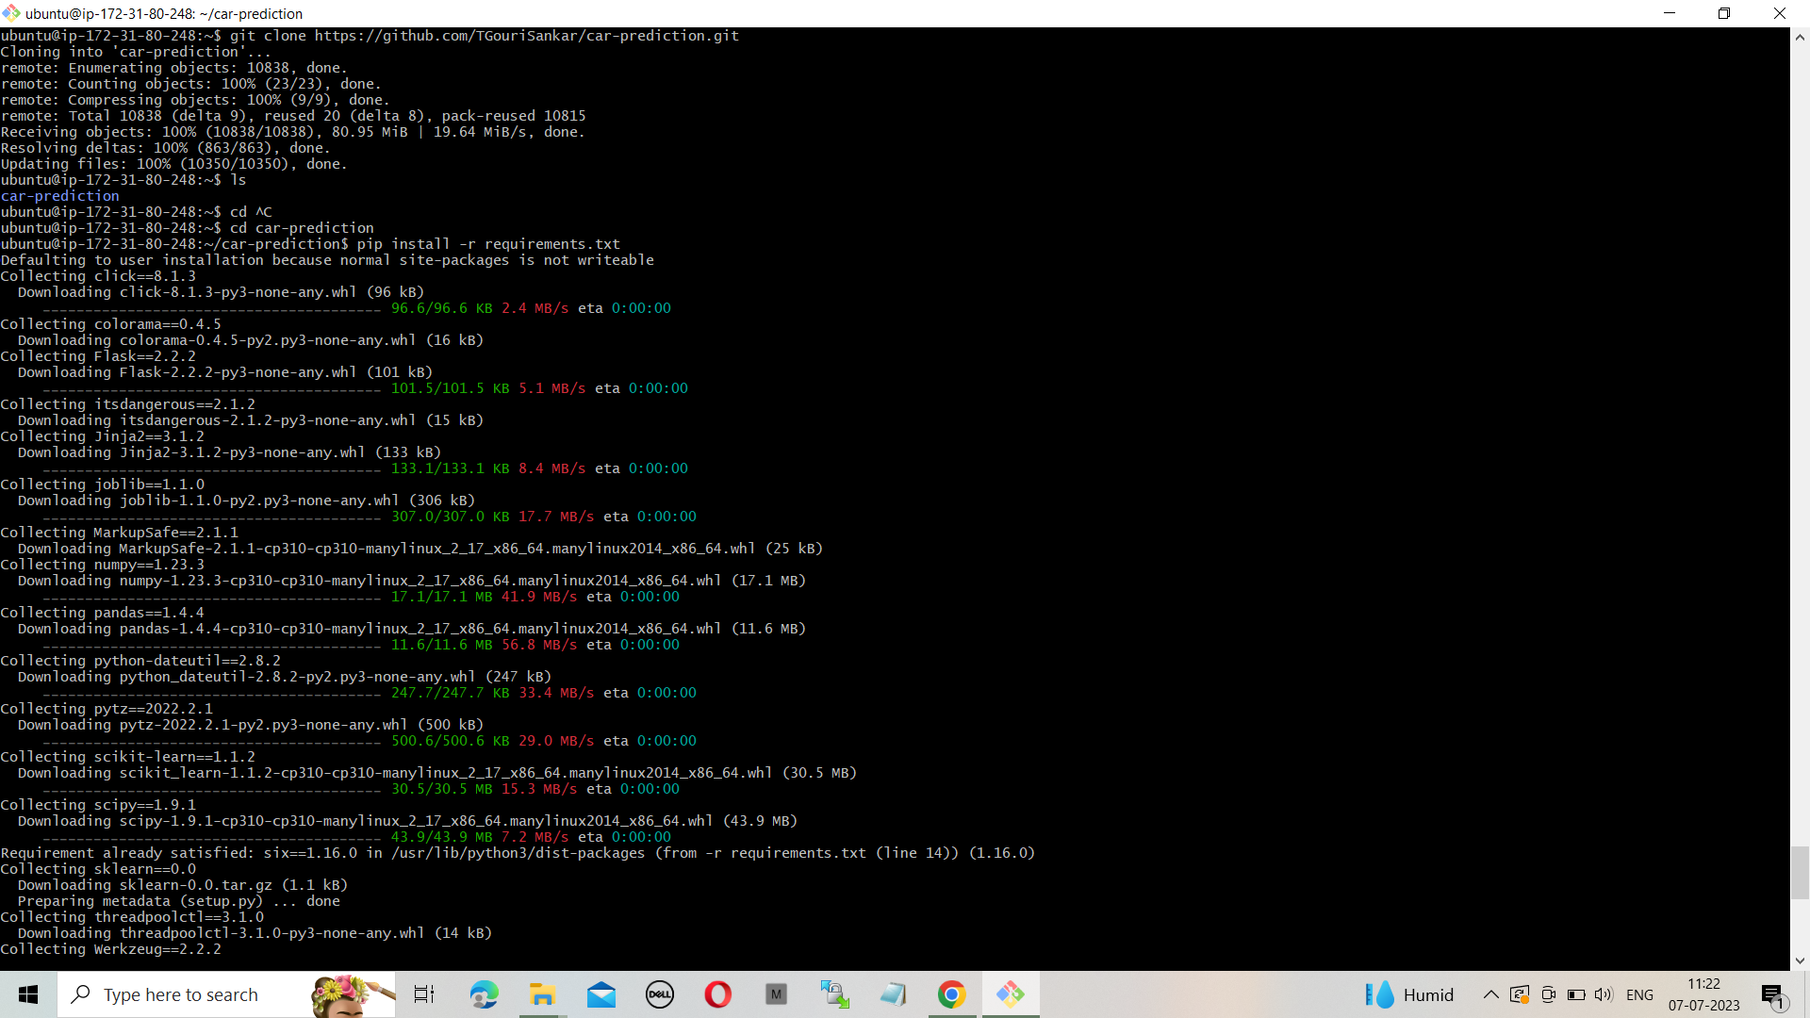

Step-8: Now run the app.py file by using the command

* screen -m -d python3 app.py

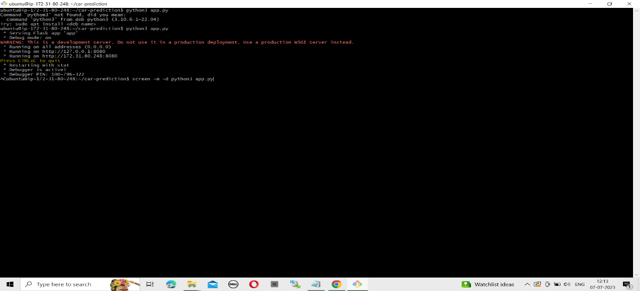

Step-9: Now go to the instance and copy the ip address and browse with the port number which is specified in the app.py file

Step-10: Now this the final output.

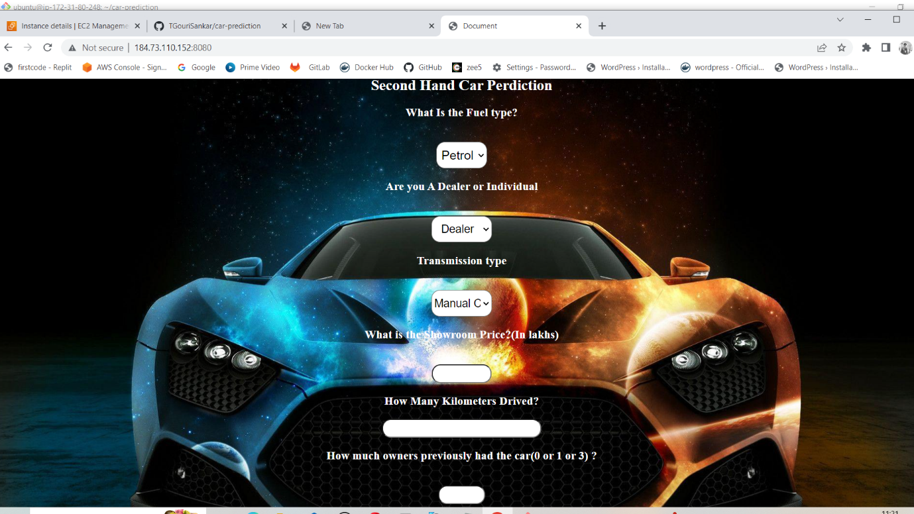

**Procedure 2: Automation**

Step-1: Install Jenkins in an instance and connect with it. Now click on the new item and select freestyle project.

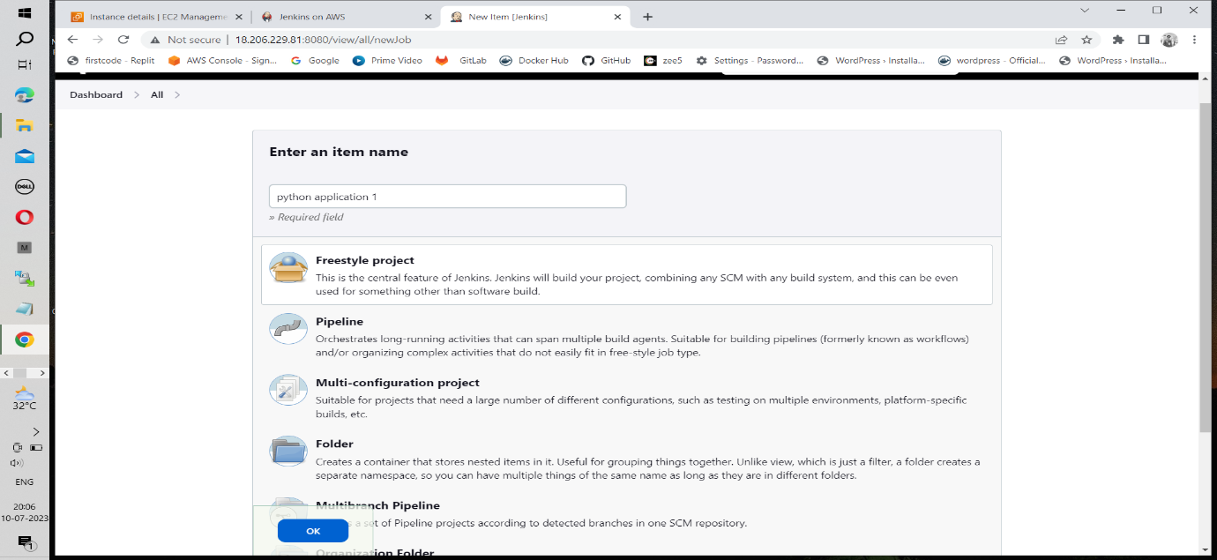

Step-2 Now select git in source code management and give the url and credentials then go to build in steps and select execute shell and give the following commands

* sudo yum update -y
* sudo yum install python3-pip -y
* pip3 install -r requirements.txt
* screen -m -d python3 app.py

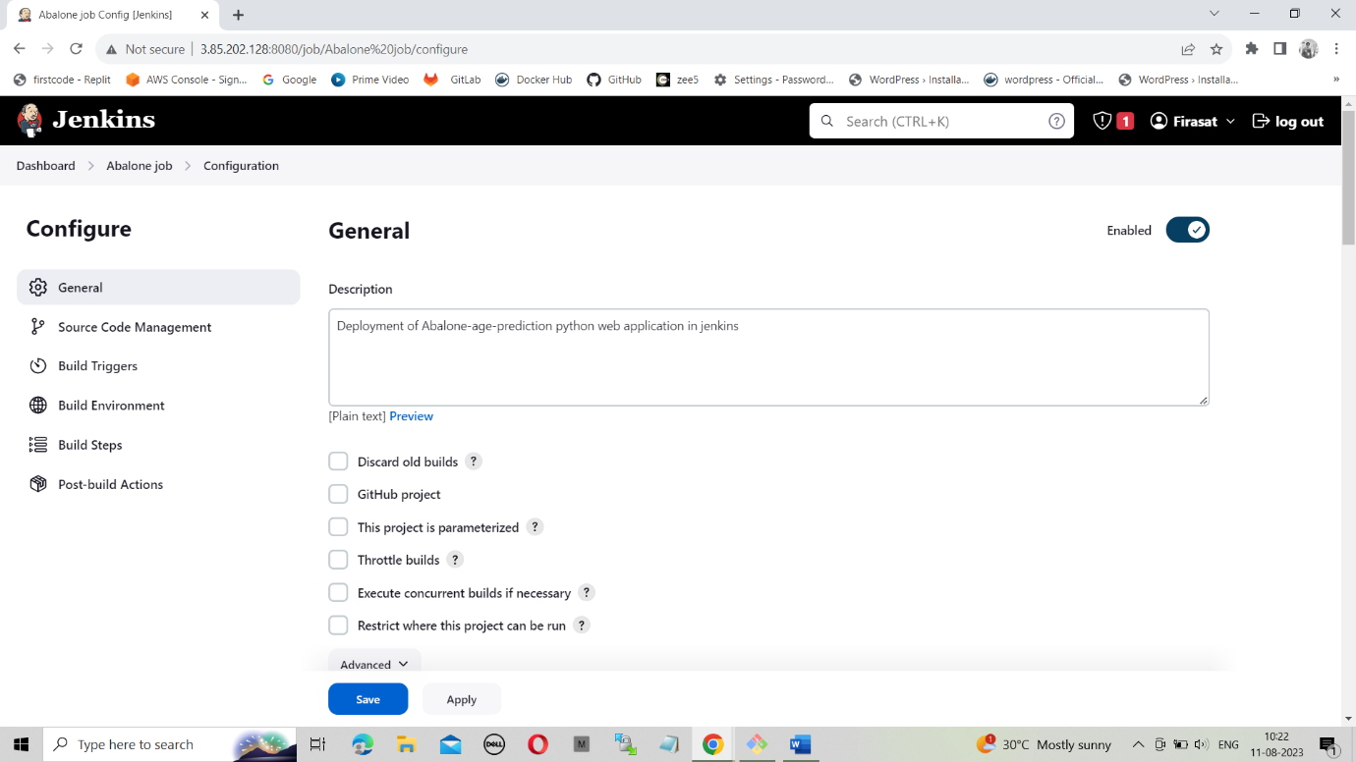

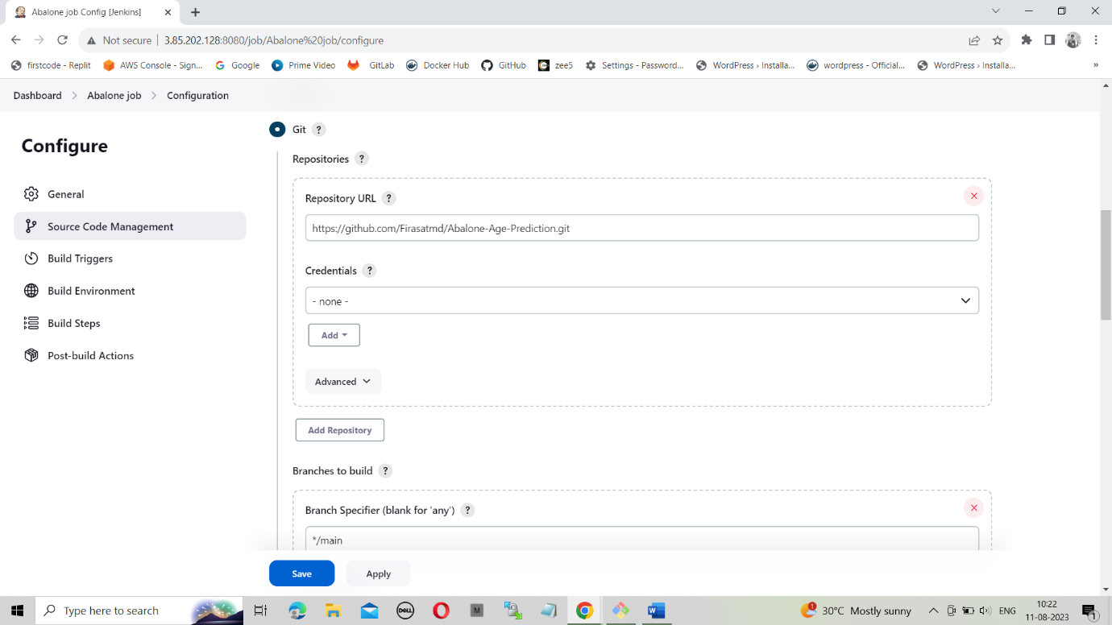

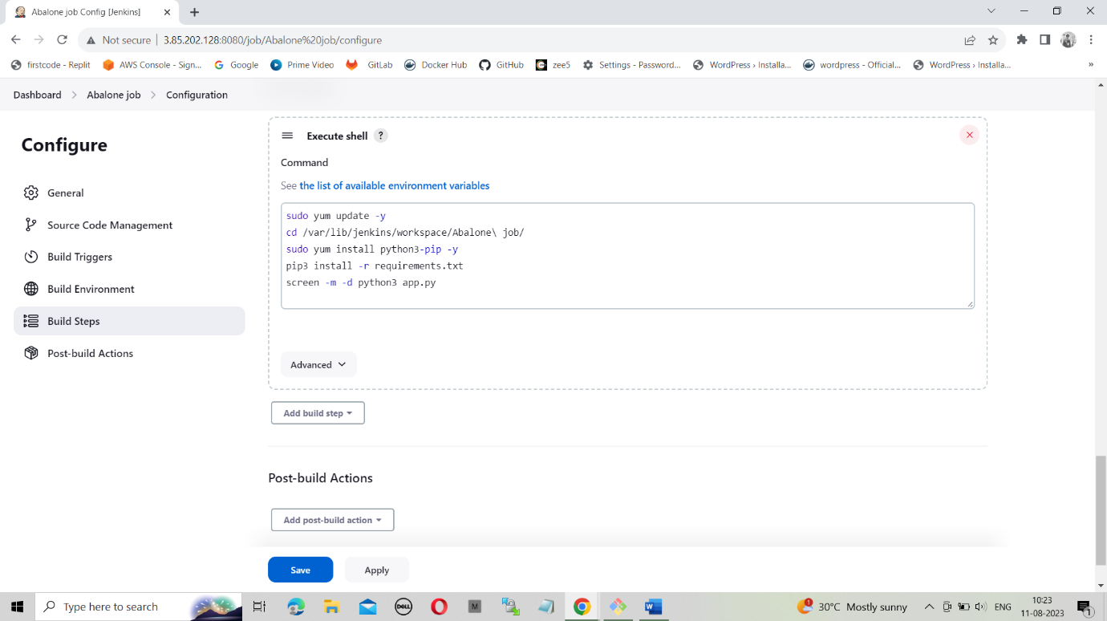

Step-3: Now build the job and check the output.

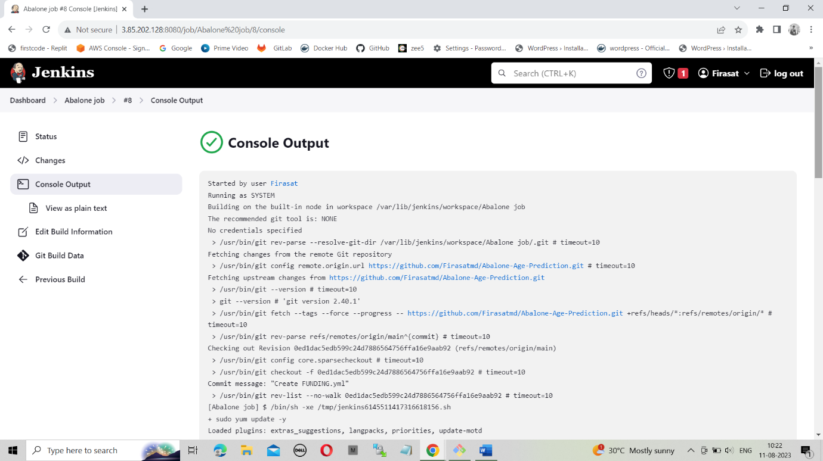

Step-4: Now browse the ip address with 8000 port to view output.



-----------------------------------------x------------------------------------------

**Procedure 3: Building with terraform**

Step-1: Create all the required terraform files and push them into a private repository and clone the python code in user data file.

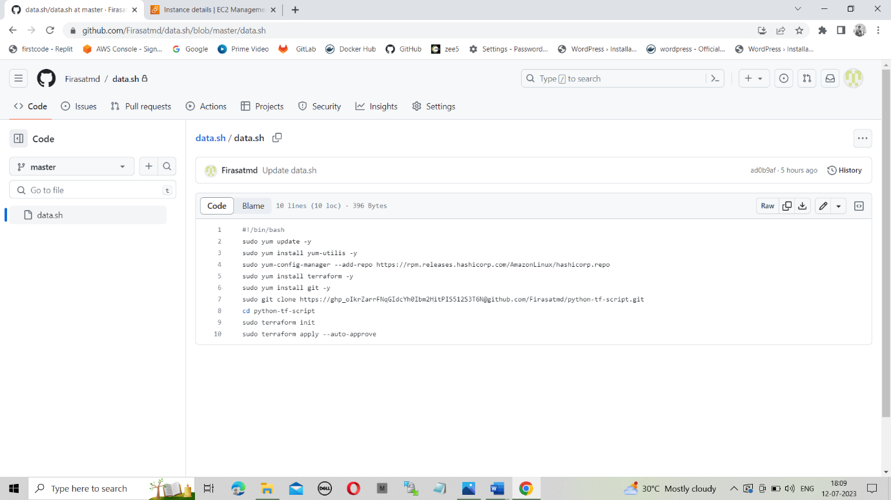Step-2: Now create another private repository and clone terraform repository in it.

Step-3: Now select new item and create a free style project.

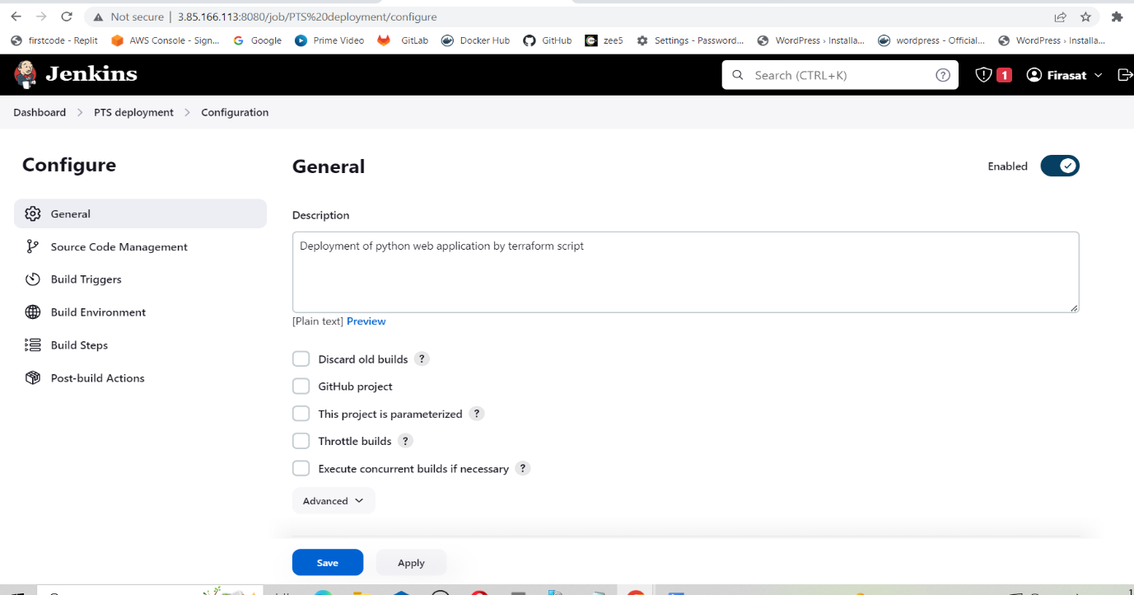

Step-4: Now select git in source code management and give the url and credentials then go to build in steps and select execute shell and give the following commands

* Sudo chmod +x ./data.sh
* ./data.sh

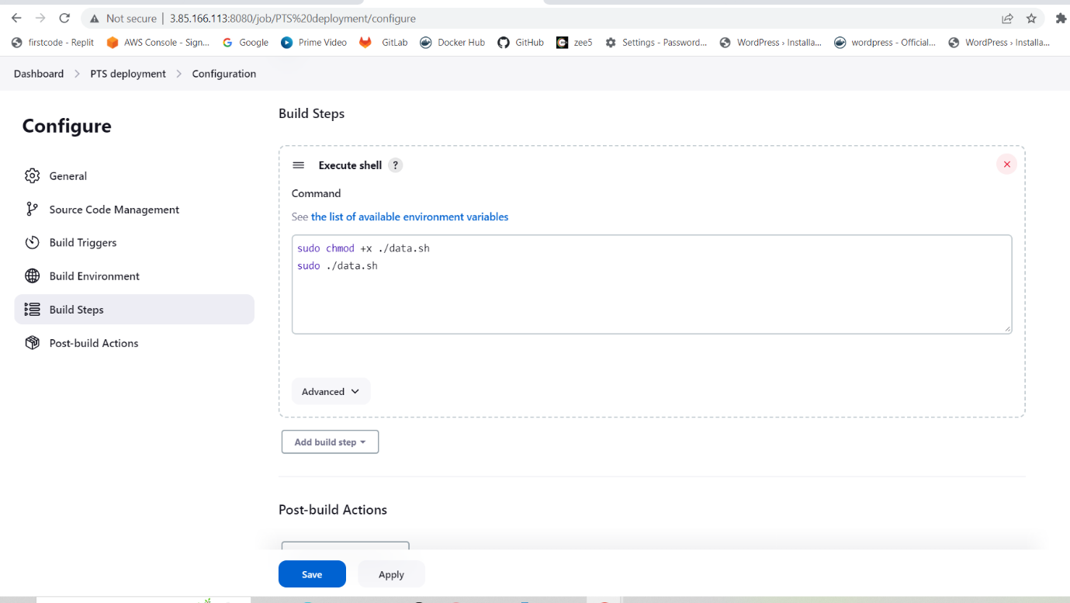

Step-5: Now build the project. After the build gets success go to aws console and copy the ip address of the instance which was created by terraform.

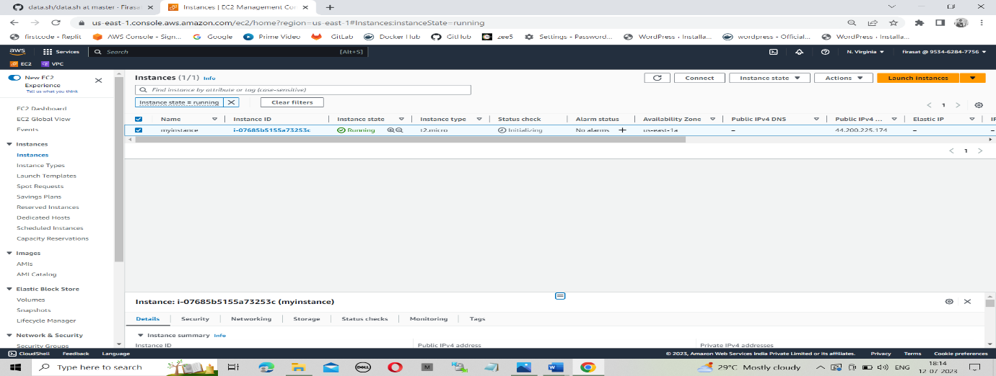

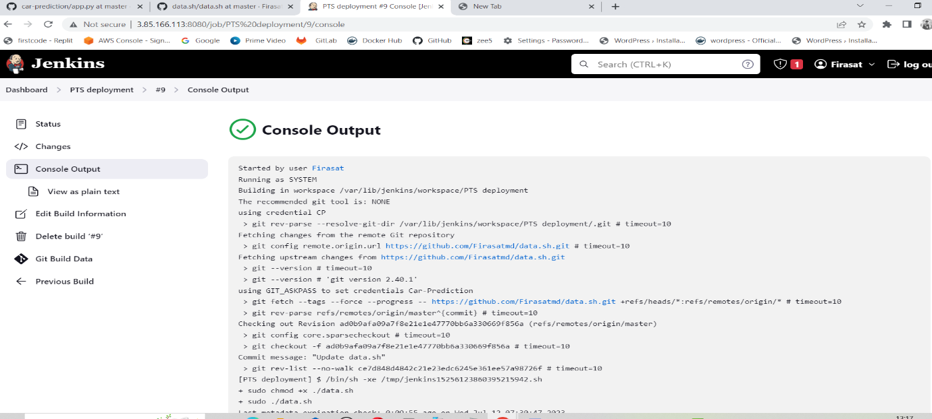

Step-6: Now this is the final output of the project.

